Module 4 – Introduction to DBMS
Introduction to SQL
- What is SQL, and why is it essential in database management?

- SQL (Structured Query Language) is a standard programming language used to store, manage, retrieve, and manipulate data in relational databases.

- Why SQL is essential in database management:
1. Data Retrieval
- SQL lets you fetch specific data using queries like SELECT.
- Example: getting all users from a table or filtering records.
2. Data Manipulation
- You can insert, update, and delete data using:
  - INSERT
  - UPDATE
  - DELETE
3. Database Structure Management
- SQL allows you to create and modify database structures:
  - CREATE (tables, databases)
  - ALTER
  - DROP
4. Data Integrity & Accuracy
- Supports constraints (like PRIMARY KEY, FOREIGN KEY) to ensure correct and consistent data.
5. Security
- You can control access using permissions (GRANT, REVOKE).
6. Standard Language
- SQL is widely used across major database systems like MySQL, PostgreSQL, and Oracle Database.
- This makes it a universal skill in IT and data-related jobs.

- Explain the difference between DBMS and RDBMS.

Feature | DBMS | RDBMS
Data Structure | Files / non-relational | Tables (relational)
Relationships | Not supported | Supported
Data Integrity | Low | High
Users | Single-user (mostly) | Multi-user
Complexity | Simple | More advanced

- Describe the role of SQL in managing relational databases.
- SQL (Structured Query Language) plays a central role in managing relational databases by acting as the main interface between users/applications and the database.

Role of SQL in Relational Databases

1. Data Retrieval
- SQL is used to query data from tables using the SELECT statement.
- Helps fetch specific records, filter results, and sort data.

2. Data Manipulation
- SQL allows you to modify data in tables:
  - INSERT → add new records
  - UPDATE → modify existing data
  - DELETE → remove records

3. Defining Database Structure
- SQL is used to create and manage tables and schemas:
  - CREATE → create tables/databases
  - ALTER → modify structure
  - DROP → delete objects

4. Managing Relationships
- In relational databases, SQL helps define relationships between tables using:
  - Primary Keys (unique identifiers)
  - Foreign Keys (link tables together)

5. Ensuring Data Integrity
- SQL enforces rules like:
  - NOT NULL
  - UNIQUE
  - CHECK
- These ensure accurate and consistent data.

6. Security and Access Control
- SQL controls who can access or modify data:
  - GRANT
  - REVOKE

7. Transaction Management
- SQL ensures safe and reliable operations using transactions:
  - COMMIT → save changes
  - ROLLBACK → undo changes

8. Works Across Popular RDBMS
- SQL is supported by systems like MySQL, PostgreSQL, and Oracle Database.

- What are the key features of SQL?
- SQL (Structured Query Language) has several important features that make it powerful for managing relational databases.

Key Features of SQL

1. Easy to Learn and Use
- SQL has a simple, English-like syntax.
- Commands like SELECT, INSERT, and DELETE are easy to understand.

2. Data Querying
- SQL allows you to retrieve specific data using powerful queries.
- Supports filtering (WHERE), sorting (ORDER BY), and grouping (GROUP BY).

3. Data Manipulation
- SQL can modify data in tables:
  - INSERT → add data
  - UPDATE → change data
  - DELETE → remove data

4. Data Definition
- SQL is used to define database structure:
  - CREATE, ALTER, DROP

5. Data Control
- Provides security and access control:
  - GRANT, REVOKE

6. Transaction Management
- SQL ensures reliable operations with:
  - COMMIT, ROLLBACK, SAVEPOINT
- Maintains database consistency.

7. Supports Relationships
- SQL works with relational databases, linking tables using:
  - Primary Keys
  - Foreign Keys

8. Standardized Language
- SQL is a universal standard supported by systems like MySQL, PostgreSQL, and Oracle Database.

9. Data Integrity
- Ensures accuracy and consistency using constraints:
  - NOT NULL, UNIQUE, PRIMARY KEY, etc.

10. Scalability and Flexibility
- Can handle small to very large databases efficiently.
- Works across different platforms and applications.

LAB EXERCISES:
Lab 1: Create a new database named school_db and a table called students with the following columns: student_id, student_name, age, class, and address.
CREATE DATABASE SCHOOLdb;
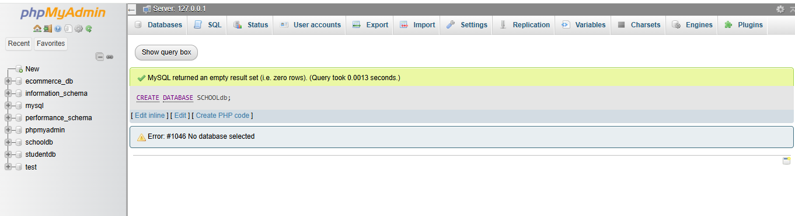
create table students(student_id int PRIMARY KEY AUTO_INCREMENT,student_name varchar(20),age int ,class varchar(20),address varchar(50))

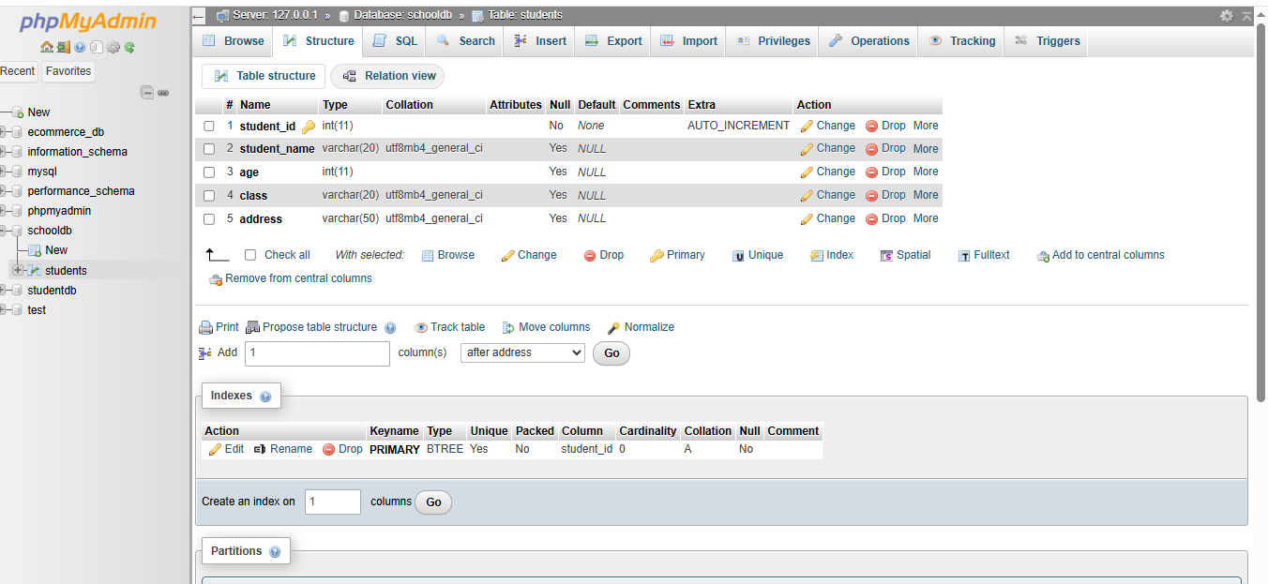
Lab 2: Insert five records into the students table and retrieve all records using the SELECT statement.
INSERT into students VALUES(1,"kenil",15,"eleven","ring road");
INSERT into students VALUES(2,"raj",13,"ten","nanpura");
INSERT into students VALUES(3,"sahil",10,"seven","bhathena,udhana");
INSERT into students VALUES(4,"yash",11,"eight","vesu");
INSERT into students VALUES(5,"neel",12,"nine","city light");
SELECT * FROM `students` ;

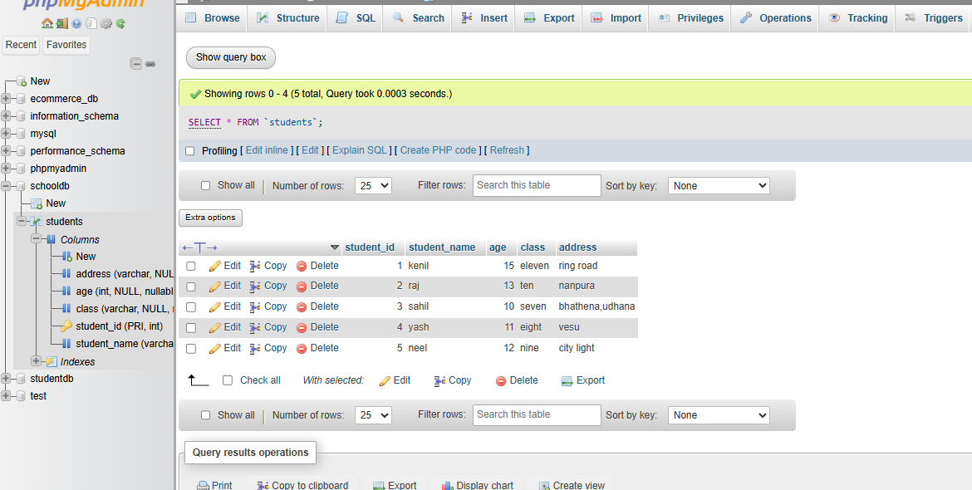

2. SQL Syntax
1. What are the basic components of SQL syntax?
Basic components of SQL syntax:
- Keywords – Special words like SELECT, FROM, WHERE
- Identifiers – Names of tables and columns
- Clauses – Parts of a query (e.g., WHERE, ORDER BY)
- Operators – Symbols like =, >, AND
- Functions – Built-in operations like COUNT(), SUM()
- Statements – Complete SQL commands (e.g., SELECT * FROM table;)
2. Write the general structure of an SQL SELECT statement ?
• SELECT
- Specifies the columns you want to retrieve
- Use * to select all columns
• FROM
- Specifies the table from which to get data
• WHERE
- Filters rows based on a condition
• GROUP BY
- Groups rows with similar values (used with functions like COUNT, SUM)
• HAVING
- Filters grouped data (used after GROUP BY)
• ORDER BY
- Sorts the result (ascending ASC or descending DESC)
3. Explain the role of clauses in SQL statements.
- Clauses are parts of an SQL query that define what data to select, from where, and how to process it. They help organize and control the query.

Main roles of clauses:
- SELECT → Chooses which columns to display
- FROM → Specifies the table to get data from
- WHERE → Filters rows based on conditions
- GROUP BY → Groups similar data together
- HAVING → Filters grouped data
- ORDER BY → Sorts the result

LAB EXERCISES:
Lab 1: Write SQL queries to retrieve specific columns (student_name and age) from the students table.
SELECT student_name,age FROM `students`;
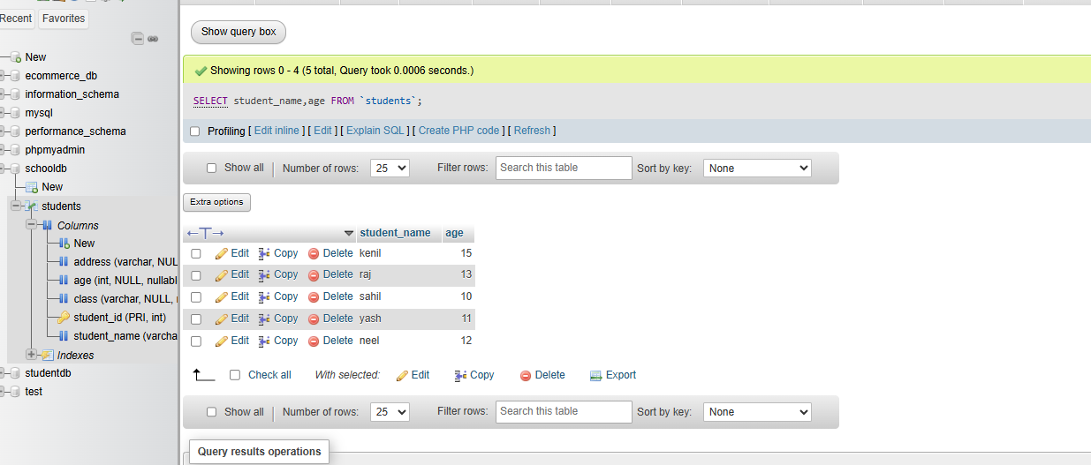
Lab 2: Write SQL queries to retrieve all students whose age is greater than 10.
SELECT * FROM `students` WHERE age > 10;
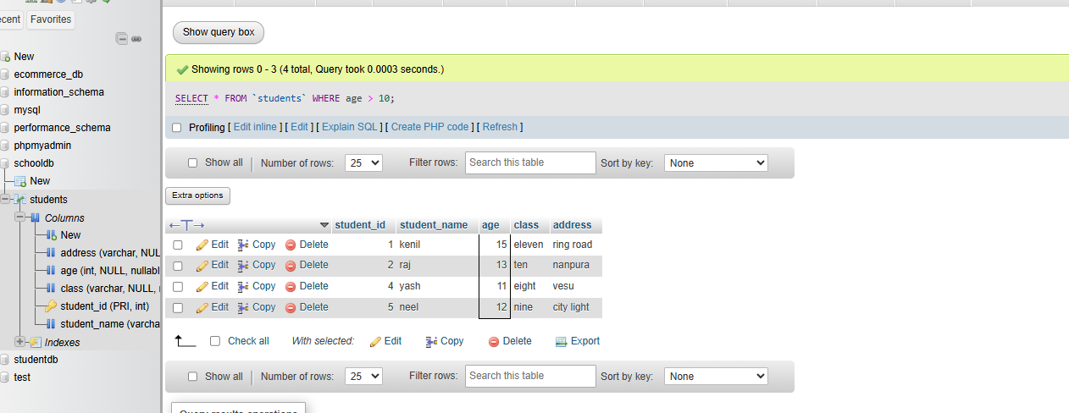

3. SQL Constraints
1. What are constraints in SQL? List and explain the different types of constraints.
- Constraints in SQL are rules applied to table columns to ensure accuracy, consistency, and integrity of data in a database.

Types of Constraints

1. NOT NULL
- Ensures a column cannot have NULL (empty) values.

2. UNIQUE
- Ensures all values in a column are different (no duplicates).

3. PRIMARY KEY
- Uniquely identifies each record in a table.
- Combination of NOT NULL + UNIQUE.
- Only one primary key per table.

4. FOREIGN KEY
- Links one table to another.
- Ensures referential integrity (valid relationship between tables).

5. CHECK
- Ensures values meet a specific condition.
- Example: age > 18

6. DEFAULT
- Assigns a default value if no value is provide.

2. How do PRIMARY KEY and FOREIGN KEY constraints differ?

PRIMARY KEY
- Uniquely identifies each record in a table
- Cannot contain NULL values
- Only one primary key per table
- Ensures entity integrity
👉 Example: student_id in a Students table

FOREIGN KEY
- Links one table to another
- Can have duplicate or NULL values
- A table can have multiple foreign keys
- Ensures referential integrity
👉 Example: student_id in a Marks table (refers to Students table)
3. What is the role of NOT NULL and UNIQUE constraints?

Role of NOT NULL and UNIQUE Constraints

NOT NULL
- Ensures a column cannot store NULL (empty) values
- Guarantees that every record must have a value
Role: Prevents missing or incomplete data

UNIQUE
- Ensures all values in a column are distinct (no duplicates)
Role: Prevents duplicate entries and maintains data uniqueness

LAB EXERCISES
Lab 1: Create a table teachers with the following columns: teacher_id (Primary Key), teacher_name (NOT NULL), subject (NOT NULL), and email (UNIQUE)
CREATE TABLE teachars(teacher_id int PRIMARY KEY AUTO_INCREMENT,teacher_name varchar(50) NOT NULL,subject varchar(50) NOT NULL,email varchar(50) UNIQUE);
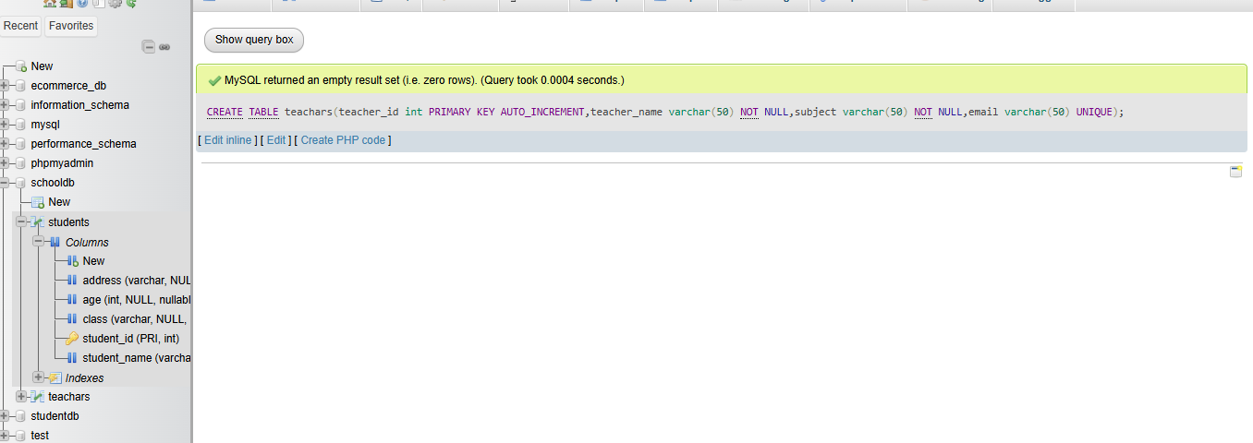
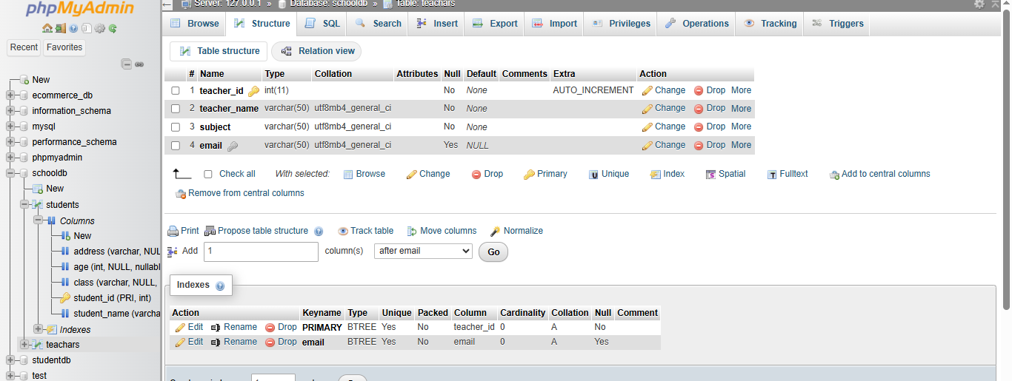

Lab 2: Implement a FOREIGN KEY constraint to relate the teacher_id from the teachers table with the students table.
CREATE TABLE enroll(eid int PRIMARY KEY AUTO_INCREMENT,stu_id int ,tea_id int ,FOREIGN KEY (stu_id)REFERENCES students(student_id),FOREIGN KEY(tea_id)REFERENCES teachars(teacher_id));
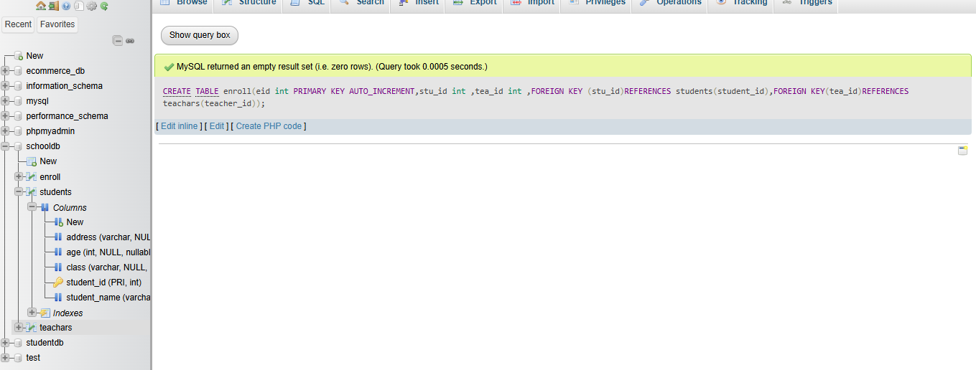

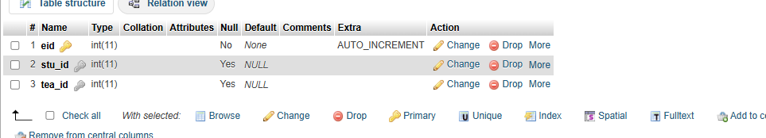
  - Main SQL Commands and Sub-commands (DDL)
- Define the SQL Data Definition Language (DDL).
SQL Data Definition Language (DDL) is a subset of SQL used to define, modify, and manage the structure of database objects such as tables, schemas, indexes, and constraints.

Common DDL Commands:
- CREATE – Creates new database objects
Example: Create a table, database, or index
- ALTER – Modifies an existing object
Example: Add or remove columns in a table
- DROP – Deletes an object permanently
Example: Remove a table or database
- TRUNCATE – Removes all records from a table but keeps its structure
- RENAME – Changes the name of a database object
- Explain the CREATE command and its syntax.

- CREATE command in SQL is used to create new database objects like tables, databases, or views.
In simple terms, it is used to make something new in the database.
Syntax:
CREATE TABLE table_name (
column1 datatype,
column2 datatype,
column3 datatype
);

- What is the purpose of specifying data types and constraints during table creation?

- Specifying data types and constraints during table creation helps to control how data is stored and maintained correctly.
- Data types define what kind of data can be stored in each column (like numbers, text, dates), ensuring the data is valid.
- Constraints set rules on the data (like NOT NULL, UNIQUE, PRIMARY KEY), helping to maintain accuracy, consistency, and prevent invalid or duplicate data.
LAB EXERCISES :
Lab 1: Create a table courses with columns: course_id, course_name, and course_credits. Set the course_id as the primary key.
CREATE TABLE courses (
course_id INT PRIMARY KEY,
course_name VARCHAR(100),
course_credits INT
);
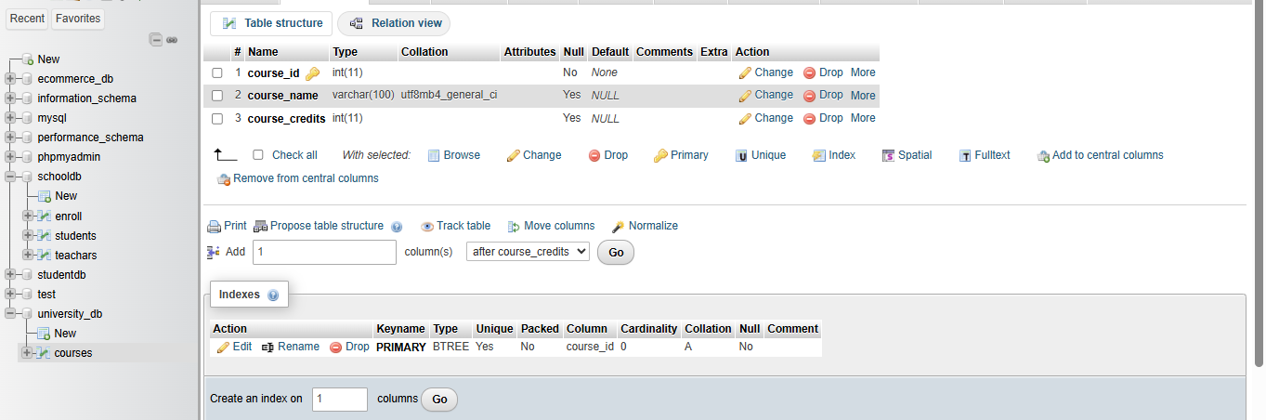
2. Use the CREATE command to create a database university_db.
CREATE DATABASE university_db;
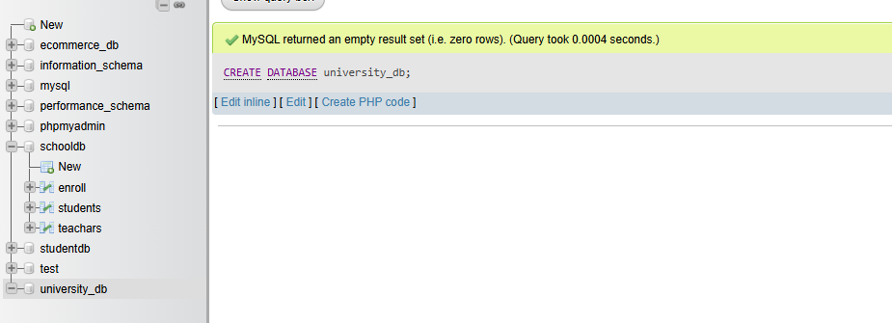
5.) ALTER Command
1. What is the use of the ALTER command in SQL?
- The ALTER command in SQL is used to modify the structure of an existing table or database object.
- It allows you to make changes after a table has already been created, without deleting it.
- Add a new column to a table
- Delete an existing column
- Modify the data type of a column
- Rename a column or table
2. How can you add, modify, and drop columns from a table using ALTER?
- In SQL, the ALTER TABLE statement is used to change the structure of an existing table, including adding, modifying, and dropping columns.

Add a column:
Use ADD to insert a new column into a table.
Example:
ALTER TABLE table_name
ADD column_name datatype;
Modify a column:
Use MODIFY (or ALTER COLUMN depending on the database) to change the datatype or constraints of an existing column.
Example (MySQL):
ALTER TABLE table_name
MODIFY column_name new_datatype;
Example (SQL Server):
ALTER TABLE table_name
ALTER COLUMN column_name new_datatype;
Drop a column:
Use DROP COLUMN to remove a column from a table.
Example:
ALTER TABLE table_name
DROP COLUMN column_name;
These commands allow you to update the table structure without deleting the table itself.

LAB EXERCISES:
Lab 1: Modify the courses table by adding a column course_duration using the ALTER command.
ALTER TABLE courses
ADD course_duration INT;
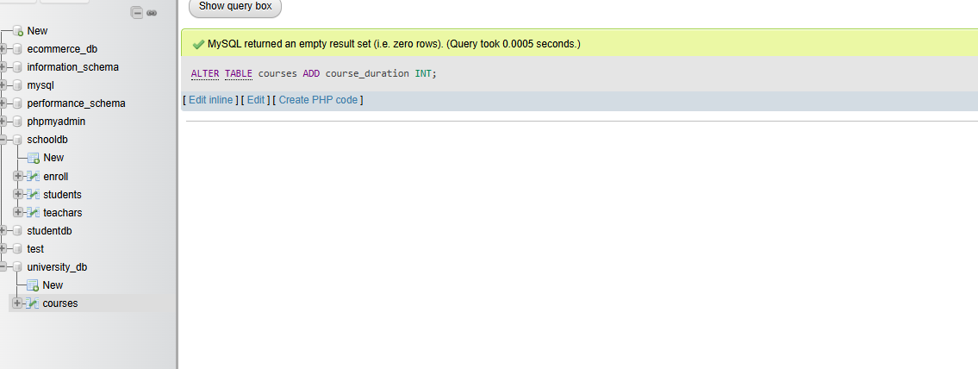
Lab 2: Drop the course_credits column from the courses table.
ALTER TABLE courses
DROP COLUMN course_credits;
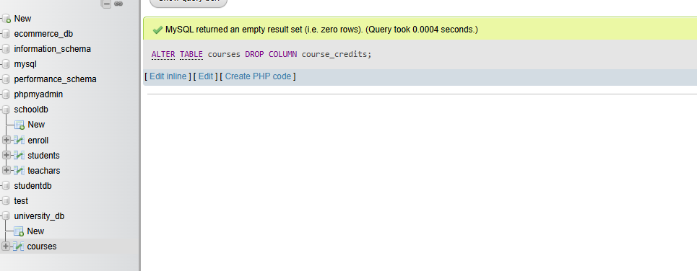

- DROP Command

  - What is the function of the DROP command in SQL?
The DROP command in SQL is used to permanently delete database objects such as tables, databases, views, or indexes.
When you use DROP, the entire object is removed from the database along with all its data and structure. This action cannot be undone, so it should be used carefully.
Example (dropping a table):
DROP TABLE table_name;
Example (dropping a database):
DROP DATABASE database_name;
  - What are the implications of dropping a table from a database?
Dropping a table in a database has several important implications:
- Permanent loss of data
All data stored in the table is completely deleted and cannot be recovered unless a backup exists.
- Removal of table structure
The table’s structure (columns, data types, constraints) is also deleted along with the data.
- Loss of dependent objects
Any indexes, triggers, or constraints associated with the table are removed automatically.
- Impact on relationships
If the table is referenced by foreign keys in other tables, dropping it may cause errors or require removing those constraints first.
- Broken queries and applications
Any SQL queries, views, or application code that depend on the table will fail after it is dropped.
- Requires caution
Since DROP is irreversible, it should be used carefully, usually after confirming backups or ensuring the table is no longer needed.

LAB EXERCISES:
Lab 1: Drop the teachers table from the school_db database.
DROP TABLE teachars;
Lab 2: Drop the students table from the school_db database and verify that the table has been removed.
DROP TABLE students;
SHOW TABLES;
DESCRIBE students;

- Data Manipulation Language (DML)

  - Define the INSERT, UPDATE, and DELETE commands in SQL.
Here are clear definitions of the three basic SQL data manipulation commands:

1. INSERT
The INSERT command is used to add new records (rows) into a table.
- It allows you to insert complete rows or specific column values.
- Example:
INSERT INTO students (id, name, age)
VALUES (1, 'Rahul', 20);

2. UPDATE
The UPDATE command is used to modify existing data in a table.
- You can update one or multiple rows using a condition.
- Example:
UPDATE students
SET age = 21
WHERE id = 1;

3. DELETE
The DELETE command is used to remove records from a table.
- You can delete specific rows using a condition, or all rows if no condition is given.
- Example:
DELETE FROM students
WHERE id = 1;

  - What isthe importance of the WHERE clause in UPDATE and DELETE operations?

The WHERE clause plays a very important role in UPDATE and DELETE operations in SQL.
It is used to specify which records in a table should be affected by the query. Without the WHERE clause, all records in the table will be updated or deleted, which can lead to serious data loss or unintended changes.
In an UPDATE statement, the WHERE clause ensures that only specific rows are modified based on a condition. For example, it allows you to update the data of only one student instead of changing all students' records.
In a DELETE statement, the WHERE clause helps remove only selected rows that meet a certain condition. Without it, the entire table data will be deleted.
Example:
UPDATE students
SET age = 20
WHERE id = 1;
DELETE FROM students
WHERE id = 1;

LAB EXERCISES:
Lab 1: Insert three records into the courses table using the INSERT command.
INSERT INTO courses (course_id, course_name, course_duration)
VALUES
(1, 'Mathematics', 12),
(2, 'Computer Science', 10),
(3, 'Physics', 8);

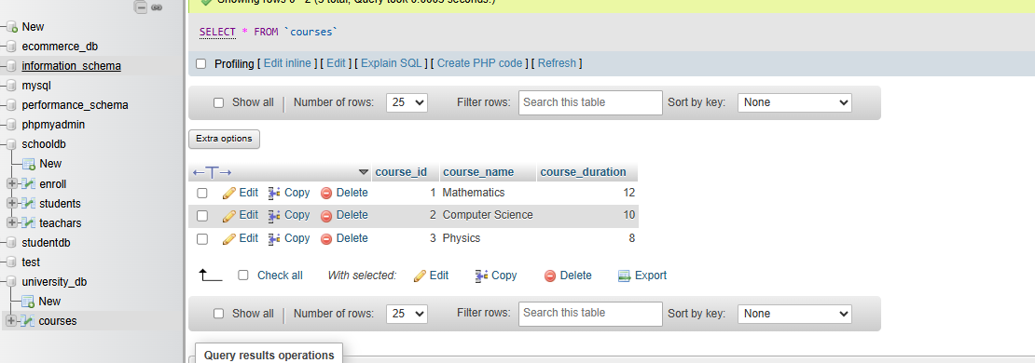

Lab 2: Update the course duration of a specific course using the UPDATE command.
UPDATE courses
SET course_duration = 14
WHERE course_id = 1;

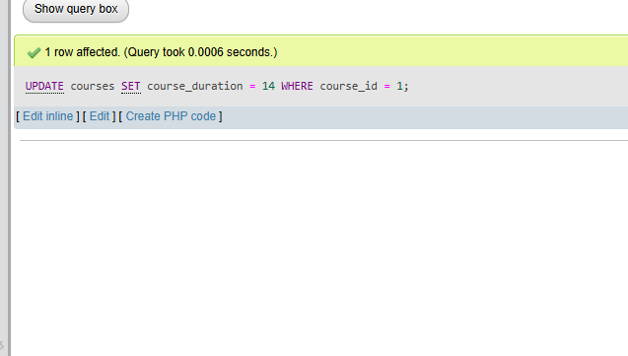

Lab 3: Delete a course with a specific course_id from the courses table using the DELETE command.

DELETE FROM courses
WHERE course_id = 2;
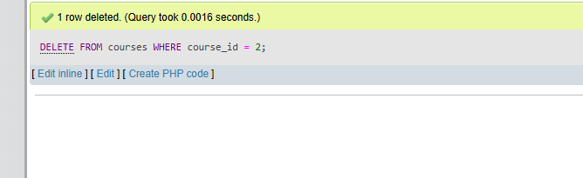

- Data Query Language (DQL)

  - What is the SELECT statement, and how is it used to query data?
The SELECT statement is used in SQL to retrieve or query data from a database table.
It allows you to fetch specific columns or all columns from one or more tables, and it can also filter, sort, and organize the data based on conditions.
Basic syntax:
SELECT column_name(s)
FROM table_name;
Example:
SELECT name, age
FROM students;
This query retrieves the name and age columns from the students table.
To select all columns:
SELECT *
FROM students;
The SELECT statement can also be used with clauses like:
- WHERE to filter records
- ORDER BY to sort data
- GROUP BY to group data
- HAVING to filter grouped data.
  - Explain the use of the ORDER BY and WHERE clauses in SQL queries.

The WHERE and ORDER BY clauses in SQL are used to filter and organize data in query results.
WHERE clause:
The WHERE clause is used to filter records based on specific conditions. It retrieves only those rows that satisfy the given condition.
Example:
SELECT * FROM table_name
WHERE column_name = value;
You can also use operators like =, >, <, >=, <=, AND, OR, and LIKE to form conditions.
ORDER BY clause:
The ORDER BY clause is used to sort the result set in ascending or descending order based on one or more columns.
Example:
SELECT * FROM table_name
ORDER BY column_name ASC;
For descending order:
SELECT * FROM table_name
ORDER BY column_name DESC;
Combined use:
Both clauses can be used together to first filter the data and then sort it.
Example:
SELECT * FROM table_name
WHERE column_name > value
ORDER BY column_name ASC;

LAB EXERCISES :
Lab 1: Retrieve all courses from the courses table using the SELECT statement.
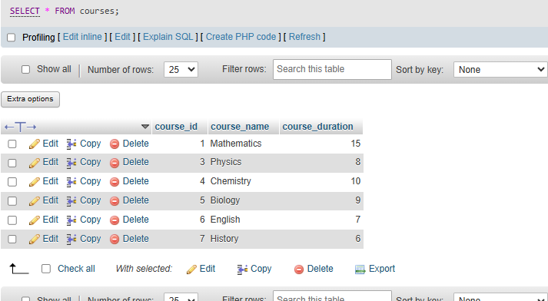

Lab 2: Sort the courses based on course_duration in descending order using ORDER BY.
SELECT * FROM courses
ORDER BY course_duration DESC;
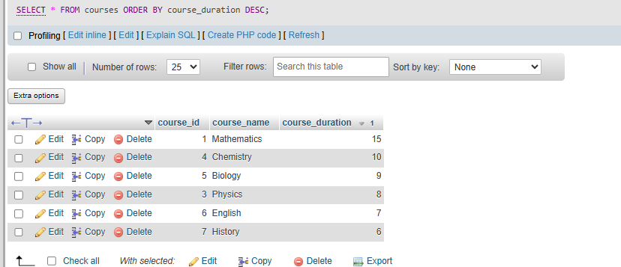
Lab 3: Limit the results of the SELECT query to show only the top two courses using LIMIT.
SELECT * FROM courses LIMIT 2;
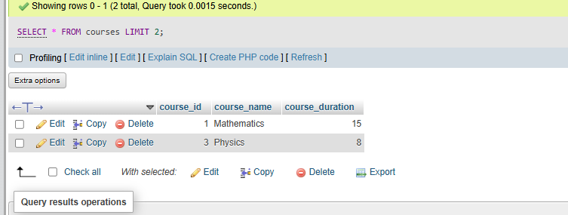
SELECT * FROM courses ORDER BY course_duration DESC LIMIT 2;
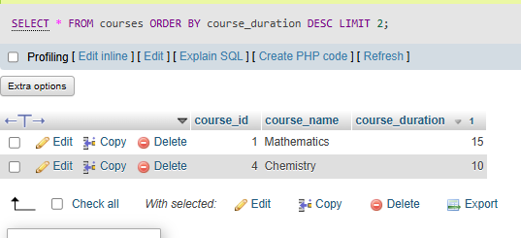

- Data Control Language (DCL)
1.What is the purpose of GRANT and REVOKE in SQL?
GRANT and REVOKE are SQL commands used to manage user permissions and access control in a database.
GRANT:
The GRANT command is used to give specific privileges to users or roles. These privileges can include actions like SELECT, INSERT, UPDATE, DELETE, or access to entire databases or tables.

Example:
GRANT SELECT, INSERT ON table_name TO user_name;
REVOKE:
The REVOKE command is used to remove previously granted privileges from users or roles.
Example:
REVOKE INSERT ON table_name FROM user_name;

  - How do you manage privileges using these commands?
Privileges in SQL are managed using the GRANT and REVOKE commands to control what users can or cannot do in a database.
Using GRANT:
You assign permissions to users or roles by specifying the type of access and the object.
Example:
GRANT SELECT, UPDATE ON table_name TO user_name;
You can also grant all privileges:
GRANT ALL PRIVILEGES ON table_name TO user_name;
Using REVOKE:
You remove specific permissions that were previously granted.
Example:
REVOKE UPDATE ON table_name FROM user_name;
You can also revoke all privileges:
REVOKE ALL PRIVILEGES ON table_name FROM user_name;
Managing privileges effectively:
You can control access at different levels such as database, table, or column.
You can assign privileges to roles and then assign roles to users for easier management.
Regularly review and update permissions to maintain security.
LAB EXERCISES:
Lab 1: Create two new users user1 and user2 and grant user1 permission to SELECT from the courses table
CREATE USER 'user1'@'localhost' IDENTIFIED BY 'password1';
CREATE USER 'user2'@'localhost' IDENTIFIED BY 'password2';
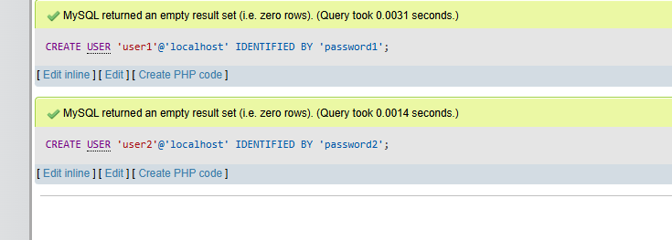
GRANT SELECT ON university_db.courses TO 'user1'@'localhost';
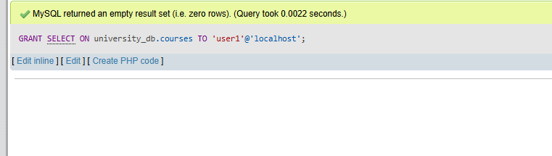
Lab 2: Revoke the INSERT permission from user1 and give it to user2.
REVOKE INSERT ON university_db.courses FROM 'user1'@'localhost';
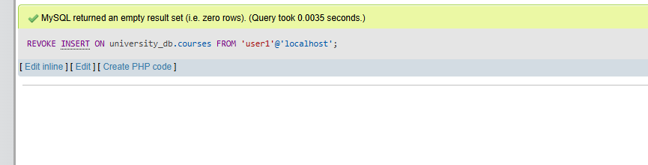
GRANT INSERT ON university_db.courses TO 'user2'@'localhost';
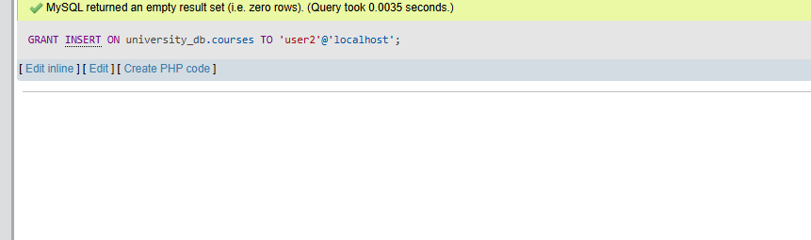

- Transaction Control Language (TCL)

  - What is the purpose of the COMMIT and ROLLBACK commands in SQL?
The COMMIT and ROLLBACK commands in SQL are used to manage transactions and ensure data consistency.
COMMIT:
The COMMIT command is used to permanently save all changes made during a transaction to the database. Once committed, the changes cannot be undone.
Example:
COMMIT;
ROLLBACK:
The ROLLBACK command is used to undo changes made during a transaction before they are committed. It restores the database to its previous state.
Example:
ROLLBACK;
  - Explain how transactions are managed in SQL databases.
Transactions in SQL databases are managed as a group of operations that are executed together as a single unit of work. This ensures that the database remains consistent even in case of errors or failures.
A transaction typically follows these steps:
Start of transaction:
A transaction begins with statements like BEGIN or START TRANSACTION.
Execution of operations:
SQL statements such as INSERT, UPDATE, or DELETE are executed as part of the transaction.
Commit:
If all operations are successful, the COMMIT command is used to save the changes permanently to the database.
Rollback:
If an error occurs or the user decides to cancel, the ROLLBACK command is used to undo all changes made during the transaction.
Transactions follow ACID properties:
Atomicity:
All operations in a transaction are completed fully or none are applied.
Consistency:
The database remains in a valid state before and after the transaction.
Isolation:
Transactions run independently without interfering with each other.
Durability:
Once a transaction is committed, the changes are permanently stored even in case of system failure.
LAB EXERCISES:
Lab 1: Insert a few rows into the courses table and use COMMIT to save the changes.
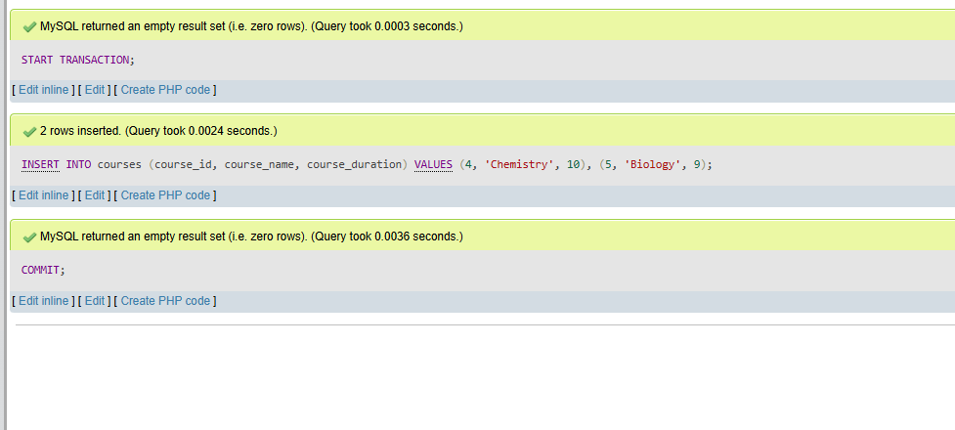
Lab 2: Insert additional rows, then use ROLLBACK to undo the last insert operation.
INSERT INTO courses (course_id, course_name, course_duration)
VALUES
(6, 'English', 7),
(7, 'History', 6);
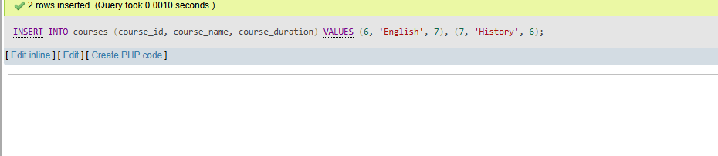
Lab 3: Create a SAVEPOINT before updating the courses table, and use it to roll back specific changes.
SAVEPOINT before_update;
UPDATE courses
SET course_duration = 15
WHERE course_id = 1;
ROLLBACK TO before_update;
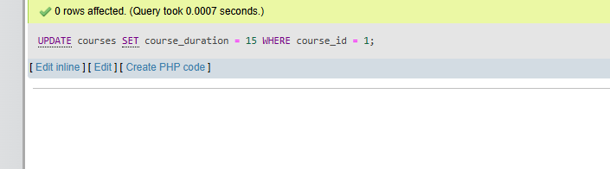

- SQL Joins

  - Explain the concept of JOIN in SQL. What is the difference between INNER JOIN, LEFT JOIN, RIGHT JOIN, and FULL OUTER JOIN?
A JOIN in SQL is used to combine data from two or more tables based on a related column between them, usually a common key.
Types of JOINs:
INNER JOIN:
Returns only the rows that have matching values in both tables. If there is no match, the row is not included.
Example:
SELECT * FROM table1
INNER JOIN table2
ON table1.id = table2.id;
LEFT JOIN (LEFT OUTER JOIN):
Returns all rows from the left table and the matching rows from the right table. If there is no match, NULL values are returned for columns from the right table.
Example:
SELECT * FROM table1
LEFT JOIN table2
ON table1.id = table2.id;
RIGHT JOIN (RIGHT OUTER JOIN):
Returns all rows from the right table and the matching rows from the left table. If there is no match, NULL values are returned for columns from the left table.
Example:
SELECT * FROM table1
RIGHT JOIN table2
ON table1.id = table2.id;
FULL OUTER JOIN:
Returns all rows from both tables. When there is no match, NULL values are filled in for the missing side.
Example:
SELECT * FROM table1
FULL OUTER JOIN table2
ON table1.id = table2.id;

  - How are joins used to combine data from multiple tables?
joins are used in SQL to combine data from multiple tables by linking them through a common column, usually a primary key in one table and a foreign key in another.
How joins work:
- Identify related tables
Two or more tables must have a logical relationship, such as a common column (e.g., customer_id).
- Use the JOIN clause
The JOIN keyword is used along with an ON condition to specify how the tables are related.
- Match rows using a condition
The ON clause defines the condition that matches rows from one table with rows from another.
Example:
SELECT customers.name, orders.order_id
FROM customers
INNER JOIN orders
ON customers.customer_id = orders.customer_id;
Explanation:
The query combines data from the customers and orders tables. It matches rows where the customer_id is the same in both tables, allowing you to see which customer placed which order.
Using multiple joins:
You can join more than two tables in a single query.
Example:
SELECT customers.name, orders.order_id, products.product_name
FROM customers
JOIN orders ON customers.customer_id = orders.customer_id
JOIN products ON orders.product_id = products.product_id;
LAB EXERCISES:
Lab 1: Create two tables: departments and employees. Perform an INNER JOIN to display employees along with their respective departments.

CREATE TABLE departments (
dept_id INT PRIMARY KEY,
dept_name VARCHAR(100)
);
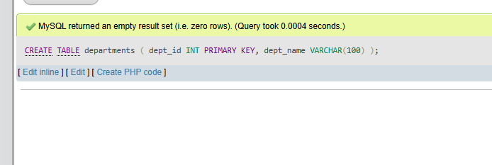
CREATE TABLE employees (
emp_id INT PRIMARY KEY,
emp_name VARCHAR(100),
dept_id INT,
FOREIGN KEY (dept_id) REFERENCES departments(dept_id)
);
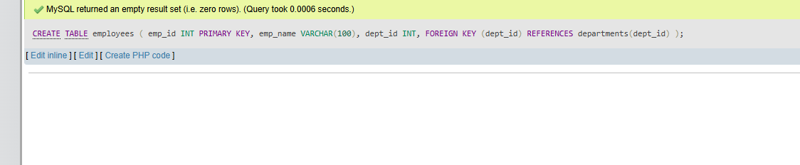

- SQL Group By

  - What is the GROUP BY clause in SQL? How is it used with aggregate functions?
The GROUP BY clause in SQL is used to group rows that have the same values in one or more columns into summary rows. It is commonly used with aggregate functions to perform calculations on each group.
Purpose of GROUP BY:
It organizes data into groups so that aggregate functions can be applied to each group instead of the entire table.
Common aggregate functions:
COUNT() – counts rows
SUM() – adds values
AVG() – calculates average
MAX() – finds highest value
MIN() – finds lowest value
Example:
SELECT column_name, COUNT(*)
FROM table_name
GROUP BY column_name;
Explanation:
This groups rows based on column_name and counts how many records are in each group.
Example with SUM:
SELECT department, SUM(salary)
FROM employees
GROUP BY department;
  - Explain the difference between GROUP BY and ORDER BY.
The GROUP BY and ORDER BY clauses in SQL serve different purposes, though they are often used together.
GROUP BY:
The GROUP BY clause is used to group rows that have the same values in one or more columns. It is mainly used with aggregate functions like COUNT, SUM, AVG, etc., to perform calculations on each group.
Example:
SELECT department, COUNT(*)
FROM employees
GROUP BY department;
Here, rows are grouped by department, and the count is calculated for each group.
ORDER BY:
The ORDER BY clause is used to sort the result set in ascending or descending order based on one or more columns.
Example:
SELECT department, COUNT(*)
FROM employees
GROUP BY department
ORDER BY department ASC;
Here, the grouped results are sorted alphabetically by department.
Key differences:
GROUP BY groups rows into categories based on column values.
ORDER BY arranges (sorts) the final result set.
GROUP BY is used with aggregate functions, while ORDER BY is used for sorting.
GROUP BY is applied before ORDER BY in query execution.
LAB EXERCISES:
Lab 1: Group employees by department and count the number of employees in each department using GROUP BY.
SELECT dept_id, COUNT(*) AS total_employees
FROM employees
GROUP BY dept_id;
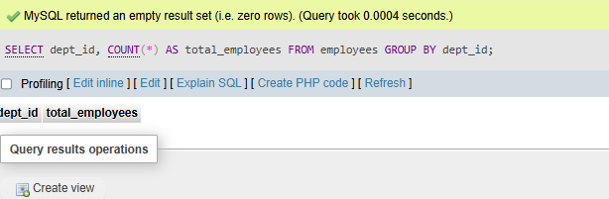
- SQL Stored Procedure

  - What is a stored procedure in SQL, and how does it differ from a standard SQL query?
A stored procedure in SQL is a precompiled collection of one or more SQL statements that are stored in the database and can be executed whenever needed.
Purpose of a stored procedure:
It is used to perform a specific task, such as inserting data, updating records, or retrieving information, often with input parameters and logic.
Example:
CREATE PROCEDURE getEmployees()
BEGIN
SELECT * FROM employees;
END;
Difference from a standard SQL query:
Stored procedure:
It is saved in the database and can be reused multiple times.
It can include multiple SQL statements, logic (loops, conditions), and parameters.
It is precompiled, so execution is faster.
It improves security by restricting direct access to tables.
Standard SQL query:
It is written and executed each time it is needed.
Usually performs a single operation.
Does not support complex programming logic like loops or conditions (in basic form).
Not stored permanently in the database.
  - Explain the advantages of using stored procedures.
Stored procedures offer several advantages in SQL databases:
- Improved performance
Stored procedures are precompiled and stored in the database, so they execute faster compared to repeatedly writing and running individual SQL queries.
- Reusability
They can be used multiple times by different applications or users, reducing code duplication.
- Reduced network traffic
Instead of sending multiple SQL statements from an application, a single call to a stored procedure can perform multiple operations, saving bandwidth.
- Better security
Users can be given permission to execute a stored procedure without granting direct access to the underlying tables, protecting sensitive data.
- Easier maintenance
Business logic is stored in one place (the database), making it easier to update and manage without changing application code.
- Support for complex logic
Stored procedures can include conditions, loops, variables, and error handling, allowing more advanced operations.
- Consistency
They ensure that the same operations are performed in a standardized way every time they are executed.
LAB EXERCISES:
Lab 1: Write a stored procedure to retrieve all employees from the employees table based on department.
DELIMITER //
CREATE PROCEDURE GetEmployeesByDepartment(IN deptId INT)
BEGIN
SELECT *
FROM employees
WHERE dept_id = deptId;
END //
DELIMITER ;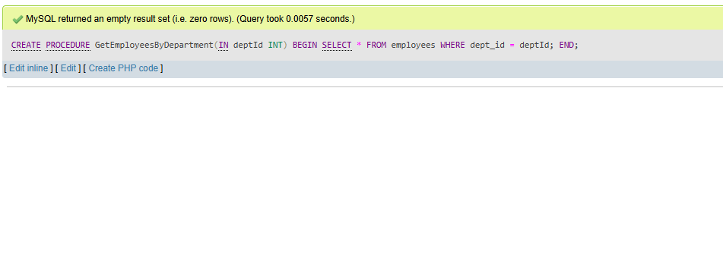
Lab 2: Write a stored procedure that accepts course_id as input and returns the course details.
DELIMITER //
CREATE PROCEDURE GetCourseById(IN c_id INT)
BEGIN
SELECT *
FROM courses
WHERE course_id = c_id;
END //
DELIMITER ;
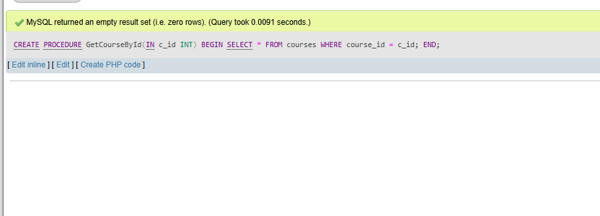

- SQL View

  - What is a view in SQL, and how is it different from a table?
A view in SQL is a virtual table created from the result of a query. It does not store data physically; instead, it displays data from one or more tables whenever it is accessed.
Example:
CREATE VIEW view_name AS
SELECT column1, column2
FROM table_name
WHERE condition;
Difference between a view and a table:
View:
It is a virtual table based on a SQL query.
It does not store actual data (only the query is stored).
It reflects changes made in the underlying tables automatically.
It is mainly used for security and simplifying complex queries.
Table:
It is a physical object in the database.
It stores actual data in rows and columns.
Data must be inserted, updated, or deleted manually.
It is used to store and manage data permanently.
  - Explain the advantages of using views in SQL databases.

- Views in SQL databases provide several advantages:
- Simplifies complex queries
Views can combine data from multiple tables and store complex SQL queries, making it easier to retrieve data without rewriting long queries.
- Improves security
Views can restrict access to specific rows or columns, allowing users to see only the data they are permitted to access instead of the entire table.
- Provides data abstraction
Views hide the underlying table structure, so users interact with a simplified representation of the data.
- Ensures consistency
Since the same view can be used by multiple users or applications, it ensures consistent results and standardized queries.
- Easy maintenance
If the underlying table structure changes, you can update the view without modifying all the queries that use it.
- No data duplication
Views do not store data physically, so they do not take up additional storage space (except for the query definition).
- Customizable data representation
Different views can present the same data in different formats based on user needs.
LAB EXERCISES:
Lab 1: Create a view to show all employees along with their department names.
CREATE VIEW employee_department_view AS
SELECT e.emp_id, e.emp_name, d.dept_name
FROM employees e
INNER JOIN departments d
ON e.dept_id = d.dept_id;
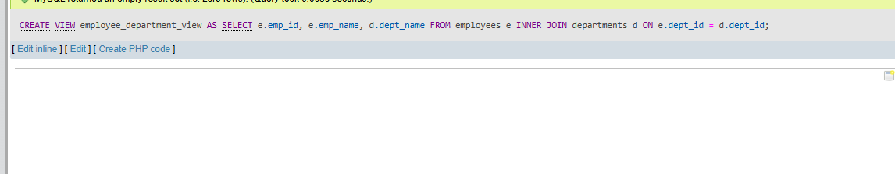
Lab 2: Modify the view to exclude employees whose salaries are below $50,000.
CREATE OR REPLACE VIEW employee_department_view AS
SELECT e.emp_id, e.emp_name, d.dept_name
FROM employees e
INNER JOIN departments d
ON e.dept_id = d.dept_id;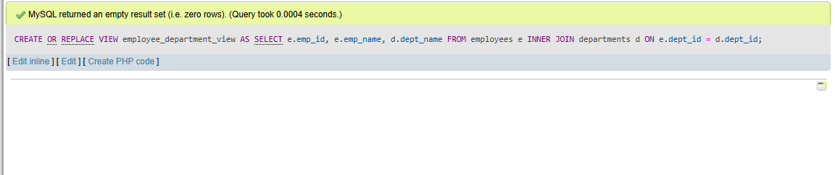

- SQL Triggers

  - What is a trigger in SQL? Describe its types and when they are used.
A trigger in SQL is a special type of stored program that automatically executes (fires) in response to certain events on a table or view, such as INSERT, UPDATE, or DELETE.
Purpose of a trigger:
Triggers are used to enforce rules, maintain data integrity, and automate actions in the database without manual intervention.
Types of triggers:
- BEFORE trigger
This trigger is executed before the specified operation (INSERT, UPDATE, DELETE) is performed.
Used when you want to validate or modify data before it is saved.
Example use: checking values before inserting a record.
- AFTER trigger
This trigger is executed after the operation has been completed.
Used when you want to perform actions after data changes, such as logging or updating related tables.
Example use: recording audit logs after a row is updated.
- INSTEAD OF trigger
This trigger is executed in place of the actual operation.
Commonly used with views to define custom behavior instead of the default action.
Example use: controlling how data is inserted into complex views.
When triggers are used:
To enforce business rules automatically
To maintain referential integrity
To keep audit trails (logs of changes)
To update related tables automatically
To validate data before or after changes
- Explain the difference between INSERT, UPDATE, and DELETE triggers.
INSERT, UPDATE, and DELETE triggers are types of triggers in SQL that differ based on the database operation that activates them.
INSERT trigger:
This trigger is fired when a new record is added to a table.
It is used to perform actions after or before inserting data.
Example use: validating data before insertion or logging new records.
UPDATE trigger:
This trigger is fired when an existing record in a table is modified.
It is used to handle changes made to existing data.
Example use: tracking changes, maintaining audit logs, or updating related data.
DELETE trigger:
This trigger is fired when a record is removed from a table.
It is used to handle actions when data is deleted.
Example use: backing up deleted data or maintaining referential integrity.
Key differences:
INSERT trigger works on adding new data.
UPDATE trigger works on modifying existing data.
DELETE trigger works on removing data.
LAB EXERCISES:
Lab 1: Create a trigger to automatically log changes to the employees table when a new employee is added.
CREATE TABLE employee_log (
log_id INT AUTO_INCREMENT PRIMARY KEY,
emp_id INT,
action VARCHAR(50),
log_time TIMESTAMP DEFAULT CURRENT_TIMESTAMP
);
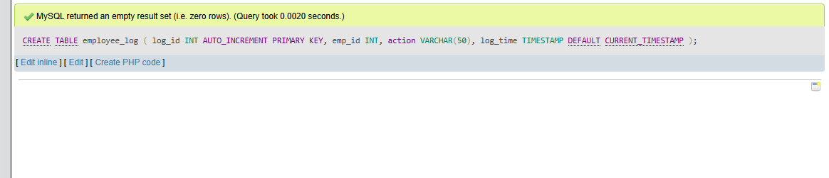
CREATE TRIGGER after_employee_insert
AFTER INSERT ON employees
FOR EACH ROW
BEGIN
INSERT INTO employee_log (emp_id, action)
VALUES (NEW.emp_id, 'Employee Added');

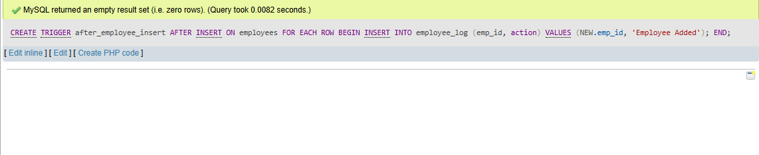
Lab 2: Create a trigger to update the last_modified timestamp whenever an employee record is updated.
ALTER TABLE employees
ADD last_modified TIMESTAMP DEFAULT CURRENT_TIMESTAMP;
DELIMITER //
CREATE TRIGGER before_employee_update
BEFORE UPDATE ON employees
FOR EACH ROW
BEGIN
SET NEW.last_modified = CURRENT_TIMESTAMP;
END //
DELIMITER ;
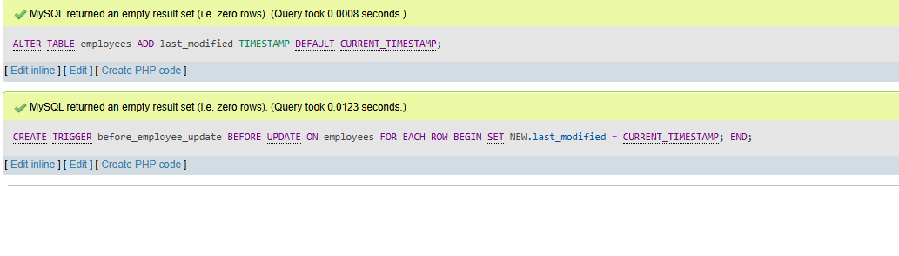
- Introduction to PL/SQL

  - What is PL/SQL, and how does it extend SQL's capabilities?
INSERT, UPDATE, and DELETE triggers are types of triggers in SQL that differ based on the database operation that activates them.
INSERT trigger:
This trigger is fired when a new record is added to a table.
It is used to perform actions after or before inserting data.
Example use: validating data before insertion or logging new records.
UPDATE trigger:
This trigger is fired when an existing record in a table is modified.
It is used to handle changes made to existing data.
Example use: tracking changes, maintaining audit logs, or updating related data.
DELETE trigger:
This trigger is fired when a record is removed from a table.
It is used to handle actions when data is deleted.
Example use: backing up deleted data or maintaining referential integrity.
Key differences:
INSERT trigger works on adding new data.
UPDATE trigger works on modifying existing data.
DELETE trigger works on removing data.
  - List and explain the benefits of using PL/SQL.
PL/SQL offers several benefits that enhance the capabilities of SQL and make database programming more efficient:
- Improved performance
PL/SQL executes multiple SQL statements in a single block, reducing communication between the application and the database, which improves performance.
- Supports procedural programming
It allows the use of loops, conditions (IF statements), and control structures, enabling complex logic to be implemented easily.
- Better error handling
PL/SQL provides exception handling mechanisms to detect and handle runtime errors, making programs more reliable.
- Code reusability
PL/SQL supports stored procedures and functions, which can be reused multiple times, reducing redundancy.
- Enhanced security
Access to data can be controlled through PL/SQL programs, allowing users to execute procedures without directly accessing tables.
- Integration with SQL
PL/SQL works seamlessly with SQL, allowing data manipulation and business logic to be combined in one program.
- Modular programming
Large programs can be divided into smaller, manageable blocks or modules, making them easier to develop and maintain.
- Maintainability
Since logic is stored in the database, updates and changes can be made in one place without modifying multiple application codes.

LAB EXERCISES:
Lab 1: Write a PL/SQL block to print the total number of employees from the employees table.
SET SERVEROUTPUT ON;
DECLARE
total_employees NUMBER;
BEGIN
SELECT COUNT(*) INTO total_employees
FROM employees;
DBMS_OUTPUT.PUT_LINE('Total Employees: ' || total_employees);
END;
Lab 2: Create a PL/SQL block that calculates the total sales from an orders table.
SELECT SUM(total_amount) AS total_sales
FROM orders;
DELIMITER //
CREATE PROCEDURE GetTotalSales()
BEGIN
SELECT SUM(total_amount) AS total_sales FROM orders;
END //
DELIMITER ;
CALL GetTotalSales();

17. PL/SQL Control Structures
1. What are control structures in PL/SQL? Explain the IF-THEN and LOOP control structures
Control structures in PL/SQL are constructs that control the flow of execution of a program. They allow decisions to be made and actions to be repeated based on certain conditions.
Types of control structures include conditional statements (like IF-THEN) and looping statements (like LOOP).
IF-THEN control structure:
The IF-THEN statement is used to execute a block of code only if a specified condition is true.
Syntax:
IF condition THEN
statements;
END IF;
You can also use additional forms:
IF-THEN-ELSE:
IF condition THEN
statements1;
ELSE
statements2;
END IF;
IF-THEN-ELSIF:
IF condition1 THEN
statements1;
ELSIF condition2 THEN
statements2;
ELSE
statements3;
END IF;
Use:
It is used for decision-making in programs.
LOOP control structure:
LOOP is used to repeatedly execute a block of code until a certain condition is met.
Basic LOOP:
LOOP
statements;
EXIT WHEN condition;
END LOOP;
WHILE LOOP:
WHILE condition LOOP
statements;
END LOOP;
FOR LOOP:
FOR counter IN start..end LOOP
statements;
END LOOP;
2.How do control structures in PL/SQL help in writing complex queries?
Control structures in PL/SQL help in writing complex queries by allowing logical decision-making, repetition, and better control over the flow of execution.
They make it possible to handle complex conditions and process data step-by-step instead of writing only simple SQL queries.
Types of control structures:
- Conditional statements
PL/SQL provides IF, IF-ELSE, and CASE statements. These allow the program to take decisions based on conditions, such as executing different queries for different values.
Example:
IF marks > 50 THEN
result := 'Pass';
ELSE
result := 'Fail';
END IF;
- Looping statements
Loops like FOR, WHILE, and LOOP allow repeated execution of a block of code. This is useful when processing multiple rows or performing repeated calculations.
Example:
FOR i IN 1..10 LOOP
DBMS_OUTPUT.PUT_LINE(i);
END LOOP;
- Exception handling
PL/SQL provides EXCEPTION blocks to handle errors. This ensures that even if an error occurs during query execution, the program can respond properly instead of crashing.
Example:
BEGIN
SELECT name INTO v_name FROM students WHERE id = 1;
EXCEPTION
WHEN NO_DATA_FOUND THEN
DBMS_OUTPUT.PUT_LINE('No record found');
END;
LAB EXERCISES:
Lab 1: Write a PL/SQL block using an IF-THEN condition to check the department of an employee.
DELIMITER //

CREATE PROCEDURE CheckEmployeeDepartment(IN empId INT)
BEGIN
DECLARE dept INT;

SELECT dept_id INTO dept
FROM employees
WHERE emp_id = empId;

IF dept = 1 THEN
SELECT 'Employee belongs to HR department' AS message;
ELSEIF dept = 2 THEN
SELECT 'Employee belongs to IT department' AS message;
ELSE
SELECT 'Employee belongs to another department' AS message;
END IF;
END //
CALL CheckEmployeeDepartment(101);
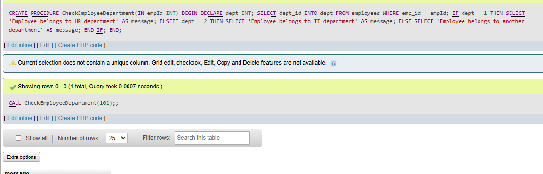
Lab 2: Use a FOR LOOP to iterate through employee records and display their names.
DELIMITER //
CREATE PROCEDURE DisplayEmployeeNames()
BEGIN
DECLARE done INT DEFAULT 0;
DECLARE empName VARCHAR(100);

DECLARE emp_cursor CURSOR FOR
SELECT emp_name FROM employees;
DECLARE CONTINUE HANDLER FOR NOT FOUND SET done = 1;
OPEN emp_cursor;
read_loop: LOOP
FETCH emp_cursor INTO empName;

IF done THEN
LEAVE read_loop;
END IF;
SELECT empName AS employee_name;
END LOOP;
CLOSE emp_cursor;
END //
DELIMITER ;
CALL DisplayEmployeeNames();
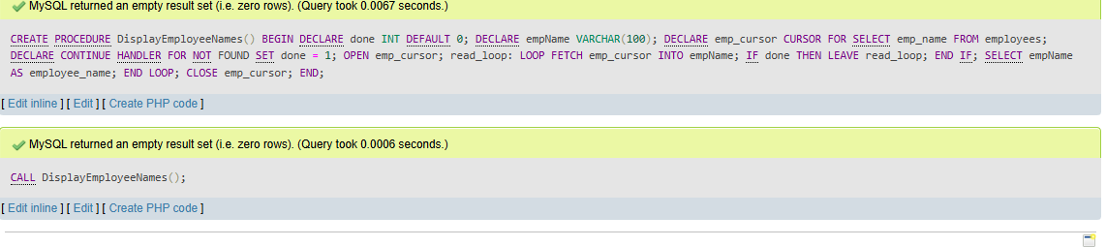
18. SQL Cursors
1. What is a cursor in PL/SQL? Explain the difference between implicit and explicit cursors
A cursor in PL/SQL is a pointer to the result set of a SQL query. It is used to retrieve and process rows returned by a query one at a time.
Cursors are useful when a query returns multiple rows and you need to handle each row individually in a program.

Types of cursors:
- Implicit cursor
An implicit cursor is automatically created and managed by Oracle whenever a SQL statement like INSERT, UPDATE, DELETE, or a SELECT statement (returning a single row) is executed.
Characteristics:
- Created automatically by the database
- No need to declare or open it
- Used for simple operations
- Provides attributes like SQL%FOUND, SQL%NOTFOUND, SQL%ROWCOUNT
Example:
UPDATE students
SET age = 20
WHERE id = 1;

- Explicit cursor
An explicit cursor is defined by the programmer for queries that return multiple rows. It must be declared, opened, fetched, and closed manually.
Steps:
- Declare the cursor
- Open the cursor
- Fetch rows from the cursor
- Close the cursor
- When would you use an explicit cursor over an implicit one?
You would use an explicit cursor over an implicit cursor when you need more control over the processing of query results, especially when dealing with multiple rows.
Situations where explicit cursors are used:
- When a query returns multiple rows
Implicit cursors are suitable for single-row operations, but when a query returns many rows, an explicit cursor is needed to process each row one by one.
- When row-by-row processing is required
If you need to perform operations on each row individually (such as calculations, validations, or conditional logic), explicit cursors are useful.
- When more control is needed
Explicit cursors allow you to control when to open, fetch, and close the cursor, giving better control over execution.
- When using loops with complex logic
If the program requires loops and conditional statements while processing data, explicit cursors are preferred.
- When working with large datasets
Explicit cursors help in handling large result sets efficiently by processing rows step by step instead of loading everything at once.
LAB EXERCISES:
Lab 1: Write a PL/SQL block using an explicit cursor to retrieve and display employee details.
DELIMITER //
CREATE PROCEDURE DisplayEmployeeDetails()
BEGIN
DECLARE done INT DEFAULT 0;
DECLARE e_id INT;
DECLARE e_name VARCHAR(100);
DECLARE d_id INT;
DECLARE emp_cursor CURSOR FOR
SELECT emp_id, emp_name, dept_id FROM employees;
DECLARE CONTINUE HANDLER FOR NOT FOUND SET done = 1;
OPEN emp_cursor;
read_loop: LOOP
FETCH emp_cursor INTO e_id, e_name, d_id;
IF done THEN
LEAVE read_loop;
END IF;
SELECT e_id AS emp_id, e_name AS emp_name, d_id AS dept_id;
END LOOP;
CLOSE emp_cursor;
END //
DELIMITER ;
CALL DisplayEmployeeDetails();
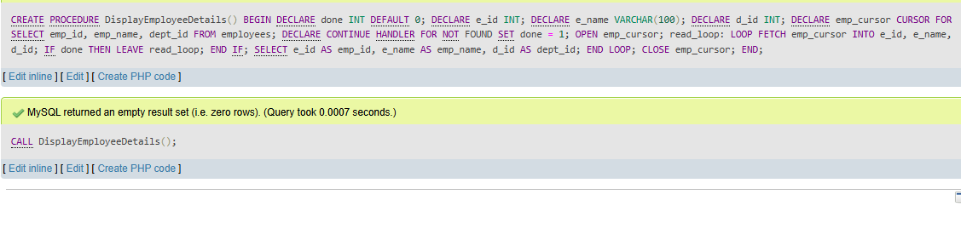

19. Rollback and Commit Savepoint
1. Explain the concept of SAVEPOINT in transaction management. How do ROLLBACK and COMMIT interact with savepoints?
A SAVEPOINT is a marker set within a transaction that allows partial rollback of the transaction instead of undoing all changes.
It is used to divide a transaction into smaller logical parts so that if an error occurs, only a specific portion of the transaction can be undone.
Interaction with ROLLBACK:
ROLLBACK can be used in two ways. When used without specifying a savepoint, it cancels the entire transaction and all changes are undone. When used with a savepoint, it rolls back only the changes made after that savepoint, preserving the earlier changes.
Interaction with COMMIT:
COMMIT permanently saves all the changes made in the transaction. Once a COMMIT is executed, all savepoints are removed and it is no longer possible to roll back to any previous savepoint.
2. When is it useful to use savepoints in a database transaction?
- Savepoints are useful in a database transaction when you want more control over how changes are undone, especially in complex operations.
- They are useful in the following situations:
- In large transactions
When a transaction involves multiple steps, savepoints allow you to roll back only a specific part instead of the entire transaction.
- When handling errors
If an error occurs at a certain step, you can roll back to a previous savepoint instead of losing all the work done before that point.
- During complex operations
In procedures or programs where multiple SQL statements are executed, savepoints help manage intermediate states safely.
- For testing or validation
You can test certain operations and, if they do not produce the expected result, roll back to a savepoint without affecting earlier valid changes.
- To maintain data consistency
Savepoints help ensure that only correct and verified parts of a transaction are kept, improving data reliability.
LAB EXERCISES:
Lab 1: Perform a transaction where you create a savepoint, insert records, then rollback to the savepoint.
START TRANSACTION;
SAVEPOINT sp1;
INSERT INTO courses (course_id, course_name, course_duration)
VALUES
(8, 'Geography', 6),
(9, 'Economics', 7);
ROLLBACK TO sp1;
COMMIT;
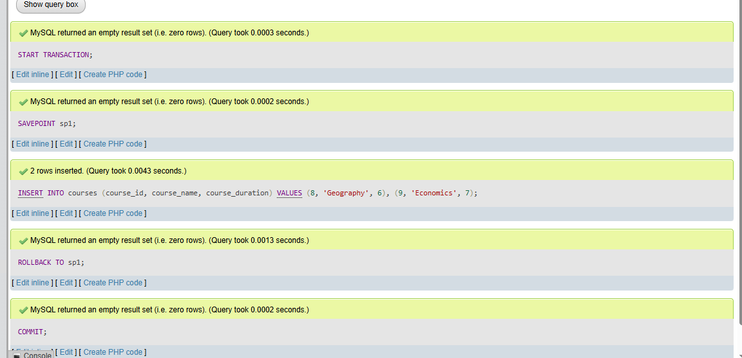

Lab 2: Commit part of a transaction after using a savepoint and then rollback the remaining changes.
START TRANSACTION;
INSERT INTO courses (course_id, course_name, course_duration)
VALUES (10, 'Statistics', 8);
SAVEPOINT sp1;
INSERT INTO courses (course_id, course_name, course_duration)
VALUES (11, 'Philosophy', 5);
ROLLBACK TO sp1;
COMMIT;
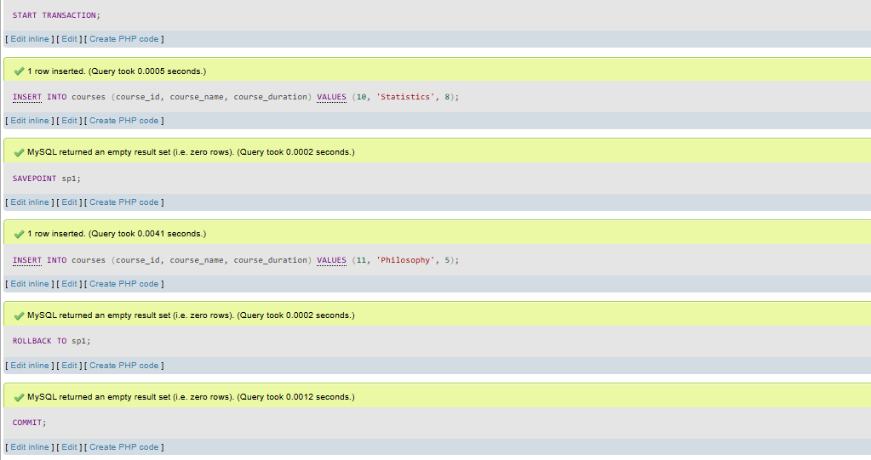

Top of Form

Bottom of Form

Top of Form

Bottom of Form

